ANNEX NO. 1 TO ENQUIRY FOR QUOTATION No. ZO023-2019-1.1.1_POIR

…………………………………………………………
Place, date

Name and address of the bidder and registration data, including Tax ID number:
…………………………………
…………………………………
…………………………………

Offer Form
A request for a valuation regarding the enquiry for quotation no. ZO023-2019-1.1.1_POIR, we make an offer to select a service for configuration of an aircraft for aerial survey solutions, integration and certification, under the project: "Research and development on the prototype technology of the multi-sensor aviation diagnostic station, enabling large-scale inventory and parameterization of vegetation" (project number: POIR.01.01.01-00-1071/17).

- Value of the offer:

Name | Net price | VAT | Gross price
Tasks of Phase 2 of the project:
• B16 - Final development of design assumptions for the aviation diagnostic station for the needs of large-area inventory and parameterization of vegetation operating in the technology of multisensory spectral-spatial measurements.
Tasks of Stage 3 of the project:
• C1 - Adaptation of design EN the aircraft to the structural assumptions developed in B16 with making the necessary certification activities consistent with the requirements of the Civil Aviation Authority.

- Proposed payment schedule:

[number of days from submitting the order] – [net amount]
[number of days from submitting the order] – [net amount]
[number of days from submitting the order] – [net amount]
[number of days from submitting the order] – [net amount]

- Place of handing over and collecting the subject of the order: ..............................

- Date of delivery: ……………………….. days

- The period of being bound by the offer: 60 days from the deadline for submission of offers.

- Declarations:
- I declare that I have read the content of the inquiry, I have no objections and have obtained the necessary information to prepare the offer.
- I declare that I accept the assumptions contained in this inquiry for the scope of the order and the requirements contained therein.
- I declare that I am in an economic and financial situation ensuring the performance of the order at the indicated time.
- I declare that I meet the conditions for participation in the procedure set out in point VI of the enquiry for quotation.

- Contact person for the contract in question for the offer:
Name:
Telephone:
e-mail:

……………………………………… date …………………………
…..……………………………………………………..
A legible signature of the authorized representative of the Bidder
and company stamp (if the entity has a stamp)

ANNEX NO. 2 TO ENQUIRY FOR QUOTATION No. ZO023-2019-1.1.1_POIR

Detailed specification and technical parameters of individual components

The subject of the order is the configuration of an aircraft for aerial survey solutions, integration and certification, the contracting party will provide a Vulcanair P68 Observer 2 equipped with three hatches intended for installation of photogrammetric mission equipment. In addition, the supplier will provide all necessary equipment along with wiring. The required length of cables will be determined by the supplier during the contract.

The scope of work planned for implementation under this contract:
Dedicated adaptation of a standard aircraft for special tasks - multi-sensor photogrammetric missions:
- Modification of the power supply to 50 Amps @ 28VDC
- Installation of one mission GPS antenna
- Modifications for mission equipment within the survey cabin configuration already EASA certified
  - Integration of one (1) stabilization mount and one (1) large format camera above the main hatch,
  - Integration of one (1) Riegl VQ 780i Laser scanner in the rear hatch (including IMU)
  - Integration of one (1) stabilization mount and one (1) medium format camera in hatch 3
  - Includes all mechanical parts for the installation of the survey equipment (wiring for the survey equipment will be provided by the client)
  - Installation of the survey equipment
- EASA certification :
  - Aircraft Flight Manual Supplements - describing all special procedures for the mission equipment
  - Aircraft Maintenance Manual Supplements - describing all special procedures for the mission equipment
  - Detailed wiring diagram - necessary electrical installation documentation for operational and maintenance purposes
  - EASA release to service (Form 53 of a Part 145)
- In addition, the order will include:
  - System design of the configuration as described
  - Detailed construction of all necessary components and assemblies
  - Integration of the mission equipment as described
  - Preparation and performance of ground tests
  - Preparation of drawings, compliance showing documents, manuals
  - Performing an in-flight tests for proper functionality of the system.

System communication block diagram:
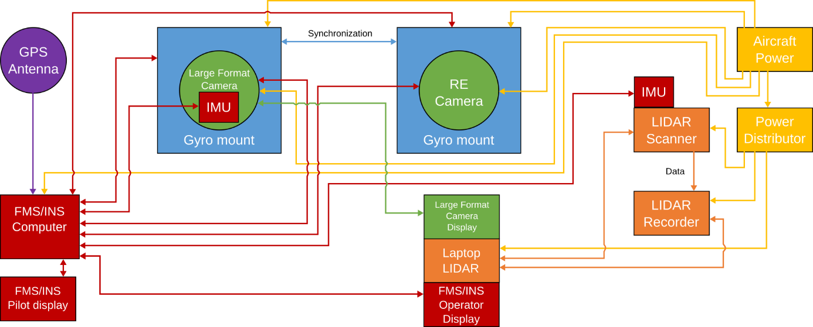

The scope of work assumes carrying out all the following works within the framework specified by the ordering party in the application for co-financing of the above project, i.e.:

Phase 2 of the project (implementation period 2019.06.01 – 2019.09.30):

B16 - Final development of design assumptions for the aviation diagnostic station for the needs of large-area inventory and parameterization of vegetation operating in the technology of multisensory spectral-spatial measurements.

Phase 3 of the project (implementation period 2019.10.01 – 2020.03.30):

C1 - Adaptation of the aerial plattform structure of the aircraft to the design assumptions developed in B16 along with the implementation of the necessary certification activities in accordance with Polish Civil Aviation Authority requirements.

The above must remain consistent with the Polish Civil Aviation Authority requirements allowing the aircraft to be used in the Republic of Poland.

General requirements for the description of the subject of the order: free of charge transportation to the ordering party and protection of the product during transportation after service. Detailed information about the subject of the order are included in Annex No. 2 to this Enquiry for quotation.

………………………………………………………………………
Date and signature of the Ordering Party
ANNEX NO. 3 TO ENQUIRY FOR QUOTATION No. ZO023-2019-1.1.1_POIR

…………………………………………………………
Place, date

Name and address of the bidder and registration data, including Tax ID number:
…………………………………
…………………………………
…………………………………

Declaration on the lack of capital and personal connections

I / We below signed hereby....................................................................................... (information about Tenderer), declare that is not related to the Ordering Party on the lack of capital and personal connections. By capital or personal connections one means the interrelationship between the Ordering Party or persons authorized to incur liabilities on behalf of the Ordering Party or persons performing on behalf of the Ordering Party activities related to the preparation and conduct of the supplier selection procedure and the supplier, consisting in particular of:
- participating in the company as a partner in a civil partnership or personal partnership,
- holding at least 10% of shares or stocks,
- performing the function of a member of the supervisory or management body, proxy, attorney,
- being married, in a direct relationship or affinity, second degree affinity or second degree relationship in the secondary kinship or in relation to adoption, care or guardianship.

The Ordering Party will assess the fulfilment by the Supplier of the above-mentioned condition for participation in the procedure according to the meets/does not meet formula - on the basis of a statement submitted by the Bidder. In the case of submitting an offer by an entity affiliated by capital or personally with the Ordering Party, he will be excluded from participation in the procedure.

……………………………………… date …………………………
…..……………………………………………………..
A legible signature of the authorized representative of the Bidder
and company stamp (if the entity has a stamp
ANNEX NO. 4 TO ENQUIRY FOR QUOTATION No. ZO023-2019-1.1.1_POIR

…………………………………………………………
Place, date

Name and address of the bidder and registration data, including Tax ID number:

…………………………………
…………………………………
…………………………………

Declaration on the authorization to represent
I / We below signed hereby declare that we are authorized to represent ....................................................................................... (information about Tenderer), including submitting the offer and submitting declarations in the procedure for the enquiry for quotation the selection of a service for configuration of an aircraft for aerial survey solutions, integration and certification, under the project: “Research and development on the prototype technology of the multi-sensor aviation diagnostic station, enabling large-scale inventory and parameterization of vegetation" (project number: POIR.01.01.01-00-1071/17).
Authorization for representation results from...................................................................................... ……………………………………………………………………………………………………………………………………………………………………………………..................................................................................................................………………

……………………………………… date …………………………
…..……………………………………………………..
A legible signature of the authorized representative of the Bidder
and company stamp (if the entity has a stamp

The information may be indicated by affixing the Tenderer’s sigil;
The Tenderer should indicate the register to which he was entered along with the number of the entry in the register, alternatively indicate on the company's agreement or other documents from which the authorization for representation arises.

